  - MRP (Material Requirements Planning)
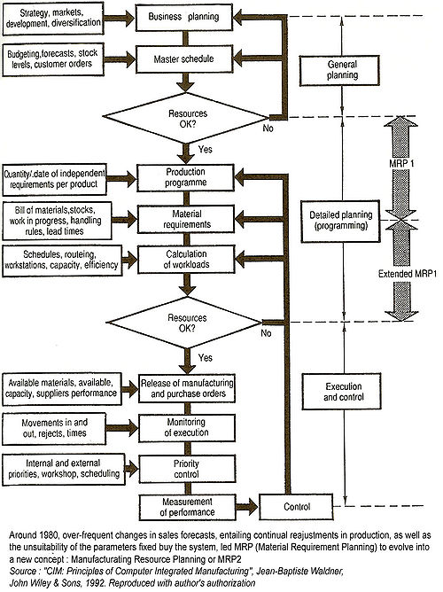
Figure: MRP Model
Manufacturing Resource Planning (MRP2 or MRPII) - Around 1980, over-frequent changes in sales forecasts, entailing continual reajustments in production, as well as the unsuitability of the parameters fixed by the system, led MRP (Material Requirements Planning) to evolve into a new concept : Manufacturing Resource Planning or MRP2
Material Requirements Planning (MRP) is a software based production planning and inventory control system used to manage manufacturing processes. Although it is not common nowadays, it is possible to conduct MRP by hand as well.
An MRP system is intended to simultaneously meet three objectives:
- Ensure materials and products are available for production and delivery to customers.
- Maintain the lowest possible level of inventory.
- Plan manufacturing activities, delivery schedules and purchasing activities.

Contents:
- 1 The scope of MRP in manufacturing
- 2 Problems with MRP systems
- 3 References

The scope of MRP in manufacturing
Manufacturing organizations, whatever their products, face the same daily practical problem - that customers want products to be available in a shorter time than it takes to make them. This means that some level of planning is required.
Companies need to control the types and quantities of materials they purchase, plan which products are to be produced and in what quantities and ensure that they are able to meet current and future customer demand, all at the lowest possible cost. Making a bad decision in any of these areas will make the company lose money. A few examples are given below:
- If a company purchases insufficient quantities of an item used in manufacturing, or the wrong item, they may be unable to meet contracts to supply products by the agreed date.
- If a company purchases excessive quantities of an item, money is being wasted - the excess quantity ties up cash while it remains as stock and may never even be used at all. However, some purchased items will have a minimum quantity that must be met, therefore, purchasing excess is necessary.
- Beginning production of an order at the wrong time can cause customer deadlines to be missed.
MRP is a tool to deal with these problems. It provides answers for several questions:
- What items are required?
- How many are required?
- When are they required?
MRP can be applied both to items that are purchased from outside suppliers and to sub-assemblies, produced internally, that are components of more complex items.
The data that must be considered include:
- The end item (or items) being created. This is sometimes called Independent Demand, or Level "0" on BOM (Bill of materials).
- How much is required at a time.
- When the quantities are required to meet demand.
- Shelf life of stored materials.
- Inventory status records. Records of net materials available for use already in stock (on hand) and materials on order from suppliers.
- Bills of materials. Details of the materials, components and subassemblies required to make each product.
- Planning Data. This includes all the restraints and directions to produce the end items. This includes such items as: Routings, Labor and Machine Standards, Quality and Testing Standards, Pull/Work Cell and Push commands, Lot sizing techniques (i.e. Fixed Lot Size, Lot-For-Lot, Economic Order Quantity), Scrap Percentages, and other inputs.
Outputs
There are two outputs and a variety of messages/reports:
- Output 1 is the "Recommended Production Schedule" which lays out a detailed schedule of the required minimum start and completion dates, with quantities, for each step of the Routing and Bill Of Material required to satisfy the demand from the MPS.
- Output 2 is the "Recommended Purchasing Schedule". This lays out both the dates that the purchased items should be received into the facility AND the dates that the Purchase orders, or Blanket Order Release should occur to match the production schedules.
Messages and Reports:
- Purchase orders. An order to a supplier to provide materials.
- Reschedule notices. These recommend cancelling, increasing, delaying or speeding up existing orders.
Note that the outputs are recommended. Due to a variety of changing conditions in companies, since the last MRP / ERP system Re-Generation, the recommended outputs need to be reviewed by trained people to group orders for benefits in set-up or freight savings. These actions are beyond the linear calculations of the MRP computer software.

Problems with MRP systems
The major problem with MRP systems is the integrity of the data. If there are any errors in the inventory data, the bill of materials (commonly referred to as 'BOM') data, or the master production schedule, then the outputted data will also be incorrect. Most vendors of this type of system recommend at least 99% data integrity for the system to give useful results.
Another major problem with MRP systems is the requirement that the user specify how long it will take a factory to make a product (NOTE: IRRESPECTIVE OF CONSIDERING PRODUCTION CAPACITY, BREAK DOWN WORKER AVAILABILITY WHICH MRP2 INCLUDES, AND PRODUCE OUTPUTS CONSIDERING ALL THESE FACTORS) from its component parts (assuming they are all available). Additionally, the system design also assumes that this "lead time" in manufacturing will be the same each time the item is made, without regard to quantity being made, or other items being made simultaneously in the factory.
A manufacturer may have factories in different cities or even countries. It is no good for an MRP system to say that we do not need to order some material because we have plenty thousands of miles away. The overall ERP system needs to be able to organize inventory and needs by individual factory, and intercommunicate needs in order to enable each factory to redistribute components in order to serve the overall enterprise.
This means that other systems in the enterprise need to work properly both before implementing an MRP system, and into the future. For example systems like variety reduction and engineering which makes sure that product comes out right first time (without defects) must be in place.
Production may be in progress for some part, whose design gets changed, with customer orders in the system for both the old design, and the new one, concurrently. The overall ERP system needs to have a system of coding parts such that the MRP will correctly calculate needs and tracking for both versions. Parts must be booked into and out of stores more regularly than the MRP calculations take place. Note, these other systems can well be manual systems, but must interface to the MRP. For example, a 'walk around' stocktake done just prior to the MRP calculations can be a practical solution for a small inventory (especially if it is an "open store").
The other major drawback of MRP is that takes no account of capacity in its calculations. This means it will give results that are impossible to implement due to manpower or machine or supplier capacity constraints. However this is largely dealt with by MRP II.
Generally, MRP II refers to a system with integrated financials. An MRP II system can include finite / infinite capacity planning. But, to be considered a true MRP II system must also include financials.
In the MRP II (or MRP2) concept, fluctuations in forecast data are taken into account by including simulation of the master production schedule, thus creating a long-term control. A more general feature of MRP2 is its extension to purchasing, to marketing and to finance (integration of all the function of the company), ERP has been the next step.

References
- ^ Waldner, Jean-Baptiste (1992). CIM: Principles of Computer Integrated Manufacturing [1]. Chichester: John Wiley & Sons Ltd. pp. p47. ISBN 047193450X.
- ^ Waldner, Jean-Baptiste (1992). CIM: Principles of Computer Integrated Manufacturing [2]. Chichester: John Wiley & Sons Ltd. pp. p46. ISBN 047193450X.

