  - Job Design and Work Measurement
Job Design and Work Measurement
KEY OUTLINE
- Job Design Decisions
  - Job Design Defined
- Behavioral Considerations in Job Design
  - Degree of Labor Specialization
  - Specialization of Labor Defined
  - Job Enrichment
  - Job Enrichment Defined
  - Sociotechnical Systems
  - Sociotechnical Systems Defined
- Physical Considerations in Job Design
  - Work Physiology Defined
  - Ergonomics Defined
- Work Methods
  - A Production Process
  - Workers at a Fixed Workplace
  - Workers Interacting with Equipment
  - Workers Interacting with Other Workers
- Work Measurements and Standards
  - Work Measurement Techniques
  - Work Measurement Defined
  - Work Sampling Compared to Time Study
  - Time Study Defined
  - Predetermined Motion Time Data Systems Defined
  - Elemental Data Defined
  - Normal Time Defined
  - Standard Time Defined
  - Work Sampling Defined
- Financial Incentive Plans
  - Basic Compensation Systems
  - Individual and Small-Group Incentive Plans
  - Organization wide Plans
- Conclusion
KEY POINTS
An operations manager uses job design techniques to structure work to meet the physical and behavioral needs of the employee. Work measurement methods are used to determine the most efficient means of performing a given task, as well as to set reasonable standards for performing it. Work performance standards are important to the workplace so accomplished can be measured and evaluated. Standards permit better planning and costing and provide a basis for compensating the work force and even providing incentives.
Trends in job design include quality as part of the worker's job. Today many workers are cross-trained to perform multi skilled jobs and total quality programs are important for all employees. Team approaches, informating, use of temporary workers, automation, and organizational commitment are other key issues in job design decisions.
Behavioral considerations in job design include how specialized a job will be. Specialization has unique advantages and disadvantages. At the other extreme from specialization are the concepts of job enlargement and job enrichment. Sociotechnical systems of the interaction between technology and the work group influence job design as do ergonomic or physical consideration.
Work methods determine how the work should be accomplished in organizations, while work measurement determines how performance may be evaluated. Work methods can be established for an overall productive system, a worker alone, a worker interacting with equipment, and a worker interacting with other individuals.
Work measurement and standards exist to set time standards for a job. A technique used in work measurement is the time study. Examples of time studies are included for a four-element job and for a nursing environment. Finally, work sampling is compared to time study.
Another issue in job design is the financial incentive plan. These plans determine how workers should be compensated. In preparing a financial incentive plan, management must consider individual, group, and organization wide rewards.
Details:
The operations manager’s job, by definition, deals with managing the personnel that create a firm’s products and services. To say that this is a challenging job in today’s complex environment is an understatement. The diversity of the workforce’s cultural and educational background, coupled with frequent organization restructuring, calls for a much higher level of people management skills than has been required in even the recent past. The objective in managing personnel is to obtain the highest productivity possible without sacrificing quality, service, or esponsiveness. The operations manager uses job design techniques to structure the work so that it will meet both the physical and behavioral needs of the human worker.Work measurement methods are used to determine the most efficient means of performing a given task, as well as to set reasonable standards for performing it. People are motivated by many things, only one of which is financial reward. Operations managers can structure such rewards not only to motivate consistently high performance but also to reinforce the most important aspects of the job.
J O B D E S I G N D E C I S I O N S
Job design:
May be defined as the function of specifying the work activities of an individual or group in an organizational setting. Its objective is to develop job structures that meet the requirements of the organization and its technology and that satisfy the jobholder’s personal and individual requirements. summarizes the decisions involved. These decisions are affected by the following trends:
1 Quality control as part of the worker’s job. Now often referred to as “quality at the source” quality control is linked with the concept of empowerment. Empowerment, in turn, refers to workers being given authority to stop a production line if there is a quality problem, or to give a customer an on-the-spot refund if service was not satisfactory.
2 Cross-training workers to perform multiskilled jobs. As companies downsize, the remaining workforce is expected to do more and different tasks.
3 Employee involvement and team approaches to designing and organizing work.
This is a central feature in total quality management (TQM) and continuous improvement efforts. In fact, it is safe to say that virtually all TQM programs are team based.
Job design
X H 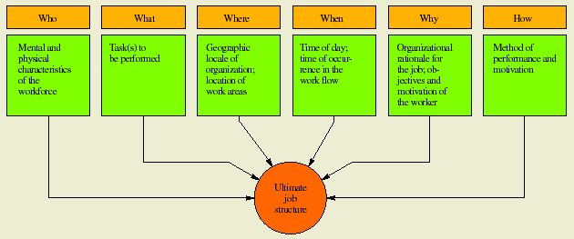
4 “Informating” ordinary workers through e-mail and the Internet, thereby expanding the nature of their work and their ability to do it. In this context, informating is more than just automating work—it is revising work’s fundamental structure. Northeast Utilities’ computer system, for example, can pinpoint a problem
in a service area before the customer service representative answers the phone. The rep uses the computer to troubleshoot serious problems, to weigh probabilities that other customers in the area have been affected, and to dispatch repair crews before other calls are even received.
5 Extensive use of temporary workers. Manpower, a company specializing in providing temporary employees, has over 1.9 million temporary employees worldwide on its payroll.
6 Automation of heavy manual work. Examples abound in both services (one-person trash pickup trucks) and manufacturing (robot spray painting on auto lines). These changes are driven by safety regulations as well as economics and personnel reasons.
7 Most important of all, organizational commitment to providing meaningful and
rewarding jobs for all employees. Companies featured on Fortune magazine’s “100 Best Companies to Work For” use creative means to keep employees satisfied, and offer generous severance and compassion when cuts must be made
B E H AV I O R A L CO N S I D E R AT I O N S I N J O B D E S I G N
D E G R E E O F L A B O R S P E C I A L I Z AT I O N
Specialization of labor is the two-edged sword of job design. On one hand, specialization has made possible high-speed, low-cost production, and from a materialistic standpoint, it has greatly enhanced our standard of living. On the other hand, extreme specialization (as we see in mass-production industries) often has serious adverse effects on workers, which in turn are passed on to management. In essence, the problem is to determine how much Specialization is enough. At what point do the disadvantages outweigh the advantages? 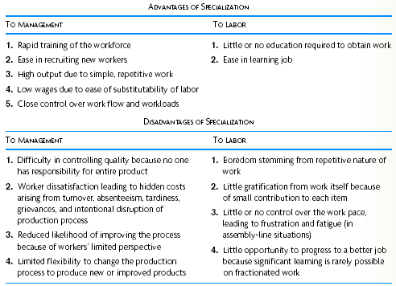
Recent research suggests that the disadvantages dominate the advantages much more commonly than was thought in the past. However, simply stating that for purely humanitarian reasons, specialization should be avoided is risky. The reason, of course, is that people differ in what they want from their work and what they are willing to put into it. Some workers prefer not to make decisions about their work, some like to daydream on the job, and others are simply not capable of performing more complex work. To improve the quality of jobs, leading organizations try different approaches to job design. Two popular contemporary approaches are job enrichment and sociotechnical systems.
J O B E N R I C H M E N T
Job enlargement generally entails adjusting a specialized job to make it more interesting to the job holder. A job is said to be enlarged horizontally if the worker performs a greater number or variety of tasks, and it is said to be enlarged vertically if the worker is involved in planning, organizing, and inspecting his or her own work. Horizontal job enlargement is intended to counteract oversimplification and to permit the worker to perform a “whole unit
of work.” Vertical enlargement (traditionally termed job enrichment) attempts to broaden workers’ influence in the transformation process by giving them certain managerial powers over their own activities. Today, common practice is to apply both horizontal and vertical enlargement to a given job and refer to the total approach as job enrichment.
The organizational benefits of job enrichment occur in both quality and productivity. Quality in particular improves dramatically because when individuals are responsible for their work output, they take ownership of it and simply do a better job. Also, because they have a broader understanding of the work process, they are more likely to catch errors and make corrections than if the job is narrowly focused. Productivity improvements also occur
from job enrichment, but they are not as predictable or as large as the improvements in quality. The reason is that enriched work invaribly contains a mix of tasks that (for manual labor) causes interruptions in rhythm and different motions when switching from one task to the next. Such is not the case for specialized jobs.1
S O C I O T E C H N I C A L S Y S T E M S
Consistent with the job enrichment philosophy but focusing more on the interaction between technology and the work group is the sociotechnical systems approach. This approach attempts to develop jobs that adjust the needs of the production process technology to the needs of the worker and work group. The term was developed from studies of weaving mills in India and of coal mines in England in the early 1950s. These studies revealed that work groups could effectively handle many production problems better than management if they were permitted to make their own decisions on scheduling, work allocation among members, bonus sharing, and so forth. This was particularly true when variations in the production process required quick reactions by the group or when one shift’s
work overlapped with other shifts’ work. Since those pioneering studies, the sociotechnical approach has been applied in many countries—often under the heading of “autonomous work groups,” “Japanese-style work
groups,” or employee involvement (EI) teams. Most major American manufacturing companies use work teams as the basic building block in so-called high employee involvement plants. They are now becoming common in service organizations as well. The benefits of teams are similar to those of individual job enrichment: They provide higher quality and greater productivity (they often set higher production goals than general management), do their own support work and equipment maintenance, and have increased chances to make meaningful improvements.2
One major conclusion from these applications is that the individual or work group requires a logically integrated pattern of work activities that incorporates the following job design principles:
1 Task variety. An attempt must be made to provide an optimal variety of tasks within each job. Too much variety can be inefficient for training and frustrating for JOB DESIGN AND WORK MEASUREMENT technical note 129 the employee. Too little can lead to boredom and fatigue. The optimal level is one that allows the employee to rest from a high level of attention or effort while working on another task or, conversely, to stretch after periods of routine activity.
2 Skill variety. Research suggests that employees derive satisfaction from using a number of skill levels.
3 Feedback. There should be some means for informing employees quickly when they have achieved their targets. Fast feedback aids the learning process. Ideally, employees should have some responsibility for setting their own standards of quantity and quality.
4 Task identity. Sets of tasks should be separated from other sets of tasks by some clear boundary. Whenever possible, a group or individual employee should have responsibility for a set of tasks that is clearly defined, visible, and meaningful. In this way, work is seen as important by the group or individual undertaking it, and others understand and respect its significance.
5 Task autonomy. Employees should be able to exercise some control over their work. Areas of discretion and decision making should be available to them.
P H YS I C A L CO N S I D E R AT I O N S I N J O B D E S I G N
Beyond the behavioral components of job design, another aspect warrants consideration: the physical side. Indeed, while motivation and work group structure strongly influence job performance, they may be of secondary importance if the job is too demanding from a physical (or “human factors”) standpoint. One approach to incorporating the physical costs of moderate to heavy work in job design is work physiology. Pioneered by Eastman Kodak in the 1960s, work physiology sets work–rest cycles according to the energy expended in various parts of the job. For example, if a job entails caloric expenditure above five calories per minute (the rough baseline for sustainable work), the required rest period must equal or exceed the time spent working. Obviously, the harder the
work, the more frequent and longer the rest periods. (Exhibit TN4.3 shows caloric requirements for various activities.)
Ergonomics is the term used to describe the study of the physical arrangement of the work space together with the tools used to perform a task. In applying ergonomics, we
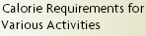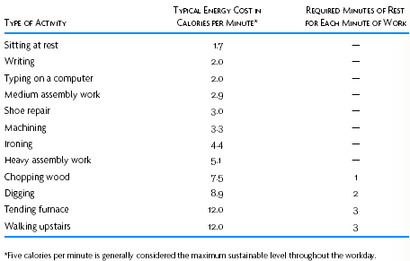
In contemporary industry, responsibility for developing work methods in large firms is typically assigned either to a staff department designated methods analysis or to an industrial engineering department. In small firms, this activity is often performed by consulting firms that specialize in work methods design. The principal approach to the study of work methods is the construction of charts, such as operations charts, worker–machine charts, simo (simultaneous motion) charts, and activity charts, in conjunction with time study or standard time data. The choice of which charting method to use depends on the task’s activity level—that is, whether the focus is on (1) a production process, (2) the worker at a fixed workplace, (3) a worker interacting with equipment, or (4) a worker interacting with other workers. Where they were used to aid in process analysis. Chapter 6 introduces the service blueprint that accounts for customer interactions.)
A P R O D U C T I O N P RO C E S S
The objective in studying a production process is to identify delays, transport distances, processes, and processing time requirements to simplify the entire operation. The underlying philosophy is to eliminate any step in the process that does not add value to the product. The approach is to flowchart the process and then ask the following questions:
What is done? Must it be done? What would happen if it were not done? Where is the task done? Must it be done at that location or could it be done somewhere else? When is the task done? Is it critical that it be done then or is there flexibility in time and sequence? Could it be combined with some other step in the process?
How is the task done? Why is it done this way? Is there another way? Who does the task? Can someone else do it? Should the worker be of a higher or lower skill level?
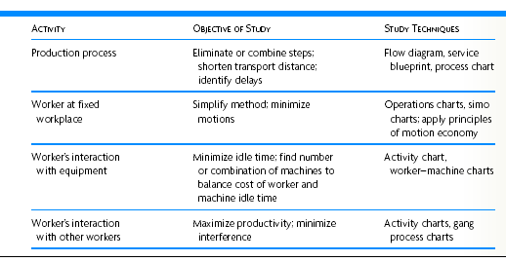
These thought-provoking questions usually help eliminate much unnecessary work and simplify the remaining work by combining processing steps and changing the order of performance. The process chart is valuable in studying an overall system, though care must be taken to follow the same item throughout the process. The subject may be a product being manufactured, a service being created, or a person performing a sequence of activities. shows a process chart (and flow diagram) for a clerical operation. shows common notation in process charting. Can you suggest any ways to improve this process?

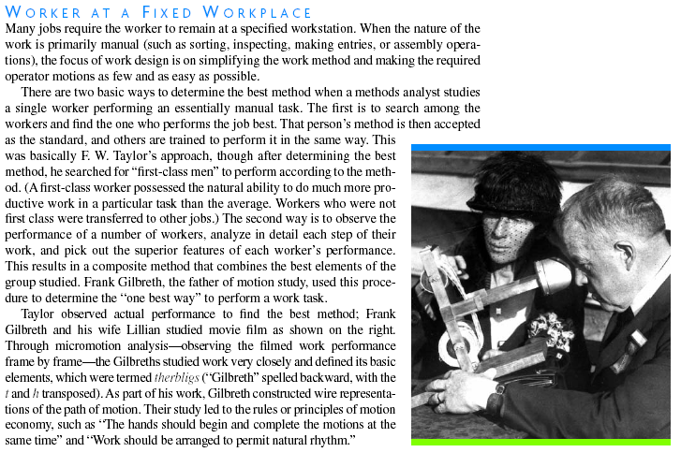
WO R K M E A S U R E M E N T A N D STANDARDS
The fundamental purpose of work measurement is to set time standards for a job. Such standards are necessary for four reasons:
1 To schedule work and allocate capacity. All scheduling approaches require some estimate of how much time it takes to do the work being scheduled.
2 To provide an objective basis for motivating the workforce and measuring workers’performance. Measured standards are particularly critical where outputbased incentive plans are employed.
3 To bid for new contracts and to evaluate performance on existing ones. Questions such as “Can we do it?” and “How are we doing?” presume the existence of standards.
4 To provide benchmarks for improvement. In addition to internal evaluation, benchmarking teams regularly compare work standards in their company with those of similar jobs in other organizations. Work measurement and its resulting work standards have been controversial since Taylor’s time. Much of this criticism has come from unions, which argue that management often sets standards that cannot be regularly achieved. (To counter this, in some contracts, the industrial engineer who sets the standard must demonstrate that he or she can do the job over a representative period of time at the rate that was set.) There is also the argument that workers who find a better way of doing the job get penalized by having a revised rate set. (This is commonly called rate cutting.) With the widespread adoption of W. Edwards Deming’s ideas, the subject has received renewed criticism. Deming argued that work standards and quotas inhibit process improvement and tend to focus the worker’s efforts on speed rather than quality. Despite these criticisms, work measurement and standards have proved effective. Much depends on sociotechnical aspects of the work. Where the job requires work groups to function as teams and create improvements, worker-set standards often make sense. On the other hand, where the job really boils down to doing the work quickly, with little need for creativity (such as delivering packages for UPS as the box on page 136 relates), tightly engineered, professionally set standards are appropriate.

WO R K E R I N T E R A C T I N G W I T H E Q U I P M E N T
When a person and equipment operate together to perform a productive process, interest focuses on the efficient use of the person’s time and equipment time. When the operator’s working time is less than the equipment run time, a worker–machine chart is a useful device in analysis. If the operator can operate several pieces of equipment, the problem is to find the most economical combination of operator and equipment, when the combined cost of the idle time of a particular combination of equipment and the idle time for the worker is at a minimum. Worker–machine charts are always drawn to scale, the scale being time as measured by length. Exhibit TN4.7 shows a worker– achine chart in a service setting. The question here is, whose utilization use is most important?
WO R K E R S I N T E R A C T I N G W I T H OT H E R WO R K E R S
The degree of interaction among teams may be as simple as one operator handing a part to another, or as complex as a cardiovascular surgical team of doctors, nurses, anesthesiologist, operator of an artificial heart machine, X-ray technician, standby blood donors, and pathologist (and perhaps a minister to pray a little). An activity or a gang process chart is useful in plotting each individual’s activities on a time scale similar to that of the worker–machine chart. A gang process chart is usually employed to trace the interaction of a number of workers with machines in a specified operating cycle to find the best combination of workers and machines. An activity chart is less restrictive and may be used to follow the interaction of any group of operators, with or without equipment being involved. Such charts are often used to study and define each operation in an ongoing repetitive process, and they are extremely valuable in developing a standardized procedure for a specific task. shows an activity chart for a hospital’s emergency routine in performing a tracheotomy (opening a patient’s throat surgically to allow the patient to breathe), where detailed activity analysis is critical and any delay could be fatal.
WO R K S A M P L I N G C O M PA R E D TO T I M E S T U DY
Work sampling offers several advantages:
1 Several work-sampling studies may be conducted simultaneously by one observer.
2 The observer need not be a trained analyst unless the purpose of the study is to determine a time standard.
3 No timing devices are required.
4 Work of a long cycle time may be studied with fewer observer hours.
5 The duration of the study is longer, which minimizes effects of short-period variations.
6 The study may be temporarily delayed at any time with little effect.
7 Because work sampling needs only instantaneous observations (made over a longer period), the operator has less chance to influence the findings by changing his or her work method.
WO R K ME A S U R E M E N T T E C H N I Q U E S
There are two common techniques for measuring work and setting standards: time study and work sampling. The choice of techniques depends on the level of detail desired and the nature of the work itself. Highly detailed, repetitive work usually calls for time study analysis. When work is infrequent or entails a long cycle time, work sampling is the tool of choice. A time study is generally made with a stopwatch, either on the spot or by analyzing a
videotape for the job. The job or task to be studied is separated into measurable parts or elements, and each element is timed individually. Some general rules for breaking down the elements are
1 Define each work element to be short in duration but long enough so that it can be timed with a stopwatch and the time can be written down.
2 If the operator works with equipment that runs separately (meaning the operator performs a task and the equipment runs independently), separate the actions of the operator and of the equipment into different elements.
3 Define any delays by the operator or equipment into separate elements. After a number of repetitions, the collected times are averaged. (The standard deviation may be computed to give a measure of variance in the performance times.) The averaged times for each element are added, yielding the performance time for the operator. However,
to make this operator’s time usable for all workers, a measure of speed or performance rating must be included to “normalize” the job. The application of a rating factor gives what is called normal time. For example, if an operator performs a task in two minutes and the time-study analyst estimates her to be performing about 20 percent faster than normal, the operator’s performance rating would be 1.2 or 120 percent of normal. The normal time would be computed as 2 minutes × 1.2, or 2.4 minutes. In equation form,
Normal time = observed performance time per unit × Performance rating
O R G A N I Z AT I O N W I D E P L A N S
Profit sharing and gain sharing are the major types of organization wide plans. Profit sharing simply distributes a percentage of corporate profits across the workforce. In the United States, at least one-third of all organizations have profit sharing. In Japan, most major companies give profit-based bonuses twice a year to all employees. Such bonuses may range from 50 percent of salaries, in good years, to nothing in bad years. but it differs from profit sharing in two important respects. First, it typically measures controllable costs or units of output, not profits, in calculating a bonus. Second, gain sharing is always combined with a participative approach to management. The original and best-known gain sharing plan is the Scanlon Plan. In the late 1930s, the Lapointe Machine and Tool Company was on the verge of bankruptcy, but through the efforts of union president Joseph Scanlon and company management, the Scanlon Plan was devised to save the company by reducing labor costs. In essence, this plan started with the normal labor cost within the firm. Workers as a group were rewarded for any reductions in labor cost below this base cost. The plan’s success depended on committees of workers throughout the firm whose purpose was to search out areas for cost saving and to devise ways of improvement. There were many improvements, and the plan did, in fact, save the company. The basic elements of the Scanlon Plan are
1 The ratio. The ratio is the standard that serves as a measure for judging business performance. It can be expressed as
Ratio = Total labor cost divided (/) Sales value of production
2 The bonus. The amount of bonus depends on the reduction in costs below the preset ratio.

THE FUN FACTOR IN SAFETY INCENTIVE PROGRAMS
Here are the basic ingredients for safety incentive programs that apply to other incentive programs as well.
1 Choose merchandise. First things first: get the carrot right. Goodyear Tire ran an extensive study on merchandise
versus cash incentives; merchandise won twofold. When you ask your people what they want, the answer will be cash. When you ask the experts what really works, it is merchandise.
2 A flexible award vehicle. Traditional programs are structured to give a person who goes a year without an accident
an award such as a clock radio. In order to attach incentives to the behavior that prevents the accidents, you must have a flexible delivery vehicle that can be awarded the minute the prevention behavior or observation takes place, yet still building up to the resulting merchandise award. Game cards that contain points toward merchandise have proved an exciting vehicle. They can be handed out weekly or daily, instantly recognizing employees as they achieve safety behavior acts or observations. If the game cards are designed right, they should have a trading component where employees are encouraged to trade cards with each other. This further boosts program awareness. Having a flexible award vehicle allows for constant frequent reinforcement, which is a key component to a program’s success.
3 An encompassing campaign. A campaign that communicates and drives the program, tying it all together, is called for. Southwest Airlines is famous for creating fun campaigns for everything it does. People love games (adults, too). The campaign theme should bring everything together: the award vehicle (game card, certificate, or the like), merchandise catalog, program posters, newsletters, communication pieces, behavioral observation reports, and so on. People remember things that are constantly in front of them, things that are fun, and things that benefit them.
4 Simple administration. Face it, complexity does not work. If your entire program is not easy for everyone to understand, you are headed in the wrong direction. If the program is tough for you to administer, it could fail as well. Keep it simple and achievable.
5 Well-thought-out, behavior-based program criteria. You first must identify the behaviors that will affect the majority
of incidents. Your program then must be aimed at gathering information/observations and receiving feedback
from employees. Employees must be rewarded for these observations as well as for feedback and, of course, for
following the accident prevention criteria. Again, keep it simple.
SOURCE: B. PEAVEY, “THE FUN FACTOR,” OCCUPATIONAL HEALTH & SAFETY 67, NO. 10 (OCTOBER 1998), P. 163.
cha06369_tn04.qxd 2/7/03 4:02 PM Page 144
3 The production committee. The production committee is formed to encourage employee suggestions to increase productivity, improve quality, reduce waste, and so forth. The purpose of a production committee is similar to that of a quality circle.
4 The screening committee. The screening committee consists of top management and worker representatives who review monthly bonuses, discuss production problems, and consider improvement suggestions. Gain-sharing plans are now used by more than a thousand firms in the United States and Europe, and are growing in popularity. One survey in the United States indicated that about 13 percent of all firms have them, and that more than 70 percent were started after 1982.5 Though originally established in small companies such as Lapointe, Lincoln Electric Company, and Herman Miller, gain sharing has been installed by large firms such as TRW, General Electric, Motorola, and Firestone. These companies apply gain sharing to organizational units. Motorola, for example, has virtually all its plant employees covered by gain sharing. These plans are increasing because “they are more than just pay incentive plans; they are a participative approach to management and are often used as a way to install
Participative management.”6 The typical applications of the plans are discussed, along with merit pay,
PAY - F O R - P E R F O R M A N C E
Business Week magazine ran a survey of compensation for company presidents. Salaries ranged from $350,000 to $8 million. In every case there was an extra “kicker” (a healthy bonus for achievement of certain goals in sales, profits, stock price, or the like). Despite gigantic salaries, every executive was offered an incentive bonus.
cha06369_tn04.qxd 2/7/03 4:02 PM Page 145

