  - Inventory Control

Inventory control
The basic function of stock (inventory) is to insulate the production process from changes in the environment as shown below.
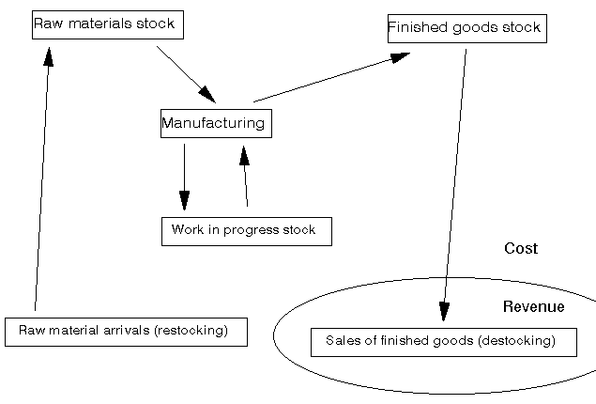
Note here that although I refer in this note to manufacturing, other industries also have stock e.g. the stock of money in a bank available to be distributed to customers, the stock of policemen in an area, etc).
One point to note from the above diagram is that most of the activities are a cost - it is only at the final point (sales of finished goods) that we get revenue to set against our costs and hopefully make a profit (= revenue - cost). Hence if we have cost associated with stock we need to deal with that stock in an Effective, Efficient and Economic manner (the 3E's as I tend to term it).
The question then arises: how much stock should we have? It is this simple question that inventory control theory attempts to answer.
There are two extreme answers to this question:
a lot
- this ensures that we never run out
- is an easy way of managing stock
- is expensive in stock costs, cheap in management costs
none/very little
- this is known (effectively) as Just-in-Time (JIT)
- is a difficult way of managing stock
- is cheap in stock costs, expensive in management costs
We shall consider the problem of ordering raw material stock but the same basic theory can be applied to the problem of:
- Deciding the finished goods stock; and
- Deciding the size of a batch in a batch production process.
The costs that we need to consider so that we can decide the amount of stock to have can be divided into stock holding costs and stock ordering (and receiving) costs as below. Note here that, conventionally, management costs are ignored here.

Holding costs - associated with keeping stock over time
- storage costs
- rent/depreciation
- labour
- overheads (e.g. heating, lighting, security)
- money tied up (loss of interest, opportunity cost)
- obsolescence costs (if left with stock at end of product life)
- stock deterioration (lose money if product deteriorates whilst held)
- theft/insurance

Ordering costs - associated with ordering and receiving an order
- clerical/labour costs of processing orders
- inspection and return of poor quality products
- transport costs
- handling costs
Note here that a stockout occurs when we have insufficient stock to supply customers. Usually stockouts occur in the order lead time, the time between placing an order and the arrival of that order.
Given a stockout the order may be lost completely or the customer may choose to backorder, i.e. to be prepared to wait until we have sufficient stock to supply their order.
Note here that whilst conceptually we can see that these cost elements are relevant it can often be difficult to arrive at an appropriate numeric figure (e.g. if the stock is stored in a building used for many other purposes, how then shall we decide an appropriate allocation of heating/lighting/security costs).
To see how we can decide the stock level to adopt consider the very simple model below.

Basic model
In this basic model we have the situation where:
- our company orders from an outside supplier;
- that outside supplier delivers to us precisely the quantity we ask for; and
- We pass that stock onto our customers (either external customers, or an internal customer within the same company (e.g. if ordering raw materials for use in the production process)).
Assume:
- Stock used up at a constant rate (R units per year)
- Fixed set-up cost c_{o} for each order - often called the order cost
- No lead time between placing an order and arrival of the order
- Variable stock holding cost c_{h} per unit per year
Then we need to decide Q, the amount to order each time, often called the batch (or lot) size.
With these assumptions the graph of stock level over time takes the form shown below.
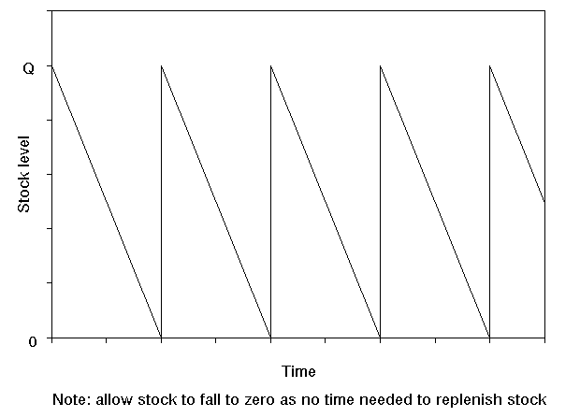
Consider drawing a horizontal line at Q/2 in the above diagram. If you were to draw this line then it is clear that the times when stock exceeds Q/2 are exactly balanced by the times when stock falls below Q/2. In other words we could equivalently regard the above diagram as representing a constant stock level of Q/2 over time.
Hence we have that:
- Annual holding cost = c_{h}(Q/2) , where Q/2 is the average (constant) inventory level
- Annual order cost = c_{o}(R/Q) , where (R/Q) is the number of orders per year (R used, Q each order)
So total annual cost = c_{h}(Q/2) + c_{o}(R/Q)
Total annual cost is the function that we want to minimise by choosing an appropriate value of Q.
Note here that, obviously, there is a purchase cost associated with the R units per year. However this is just a constant as R is fixed so we can ignore it here.
The diagram below illustrates how these two components (annual holding cost and annual order cost) change as Q, the quantity ordered, changes. As Q increases holding cost increases but order cost decreases. Hence the total annual cost curve is as shown below - somewhere on that curve lies a value of Q that corresponds to the minimum total cost.
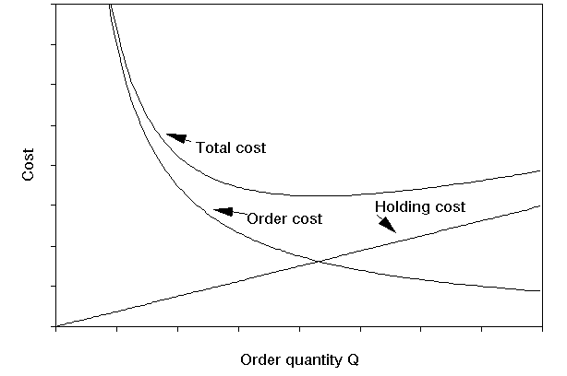
We can calculate exactly which value of Q corresponds to the minimum total cost by differentiating total cost with respect to Q and equating to zero.
d(total cost)/dQ = c_{h}/2 - c_{o}R/Q² = 0 for minimisation
which gives Q² = 2c_{o}R/c_{h}
Hence the best value of Q (the amount to order = amount stocked) is given by
- Q =(2Rc_{o}/c_{h})^{0.5}
and this is known as the Economic Order Quantity (EOQ)

Comments
This formula for the EOQ is believed to have been first derived in the early 1900's and so EOQ dates from the beginnings of mass production/assembly line production.
To get the total annual cost associated with the EOQ we have from before that total annual cost = c_{h}(Q/2) + c_{o}(R/Q) so putting Q =(2Rc_{o}/c_{h})^{0.5} into this we get that the total annual cost is given by
c_{h}((2Rc_{o}/c_{h})^{0.5}/2) + c_{o}(R/(2Rc_{o}/c_{h})^{0.5}) = (Rc_{o}c_{h}/2)^{0.5} + (Rc_{o}c_{h}/2)^{0.5} = (2Rc_{o}c_{h})^{0.5}
Hence total annual cost is (2Rc_{o}c_{h})^{0.5} which means that when ordering the optimal (EOQ) quantity we have that total cost is proportional to the square root of any of the factors (R, c_{o} and c_{h}) involved. For example, if we were to reduce c_{o} by a factor of 4 we would reduce total cost by a factor of 2 (note the EOQ would change as well). This, in fact, is the basis of Just-in-Time (JIT), to reduce (continuously) c_{o} and c_{h} so as to drive down total cost.
To return to the issue of management costs being ignored for a moment the basic justification for this is that if we consider the total cost curve shown above, then - assuming we are not operating a policy with a very low Q (JIT) or a very high Q - we could argue that the management costs are effectively fixed for a fairly wide range of Q values. If this is so then such costs would not influence the decision as to what order quantity Q to adopt. Moreover if we wanted to adopt a more quantitative approach we would need some function that captures the relationship between the management costs we incur and our order quantity Q - estimating this function would certainly be a non-trivial task.

Example
A retailer expects to sell about 200 units of a product per year. The storage space taken up in his premises by one unit of this product is costed at £20 per year. If the cost associated with ordering is £35 per order what is the economic order quantity given that interest rates are expected to remain close to 10% per year and the total cost of one unit is £100.
We use the EOQ formula,
EOQ = (2Rc_{o}/c_{h})^{0.5}
Here R=200, c_{o}=35 and the holding cost c_{h} is given by
c_{h} = £20 (direct storage cost per unit per year) + £100 x 0.10 (this term the money interest lost if one unit sits in stock for one year)
i.e. c_{h} = £30 per unit per year
Hence EOQ = (2Rc_{o}/c_{h})^{0.5} = (2 x 200 x 35/30)^{0.5} = 21.602
But as we must order a whole number of units we have that:
EOQ = 22
We can illustrate this calculation by reference to the diagram below which shows order cost, holding cost and total cost for this example.
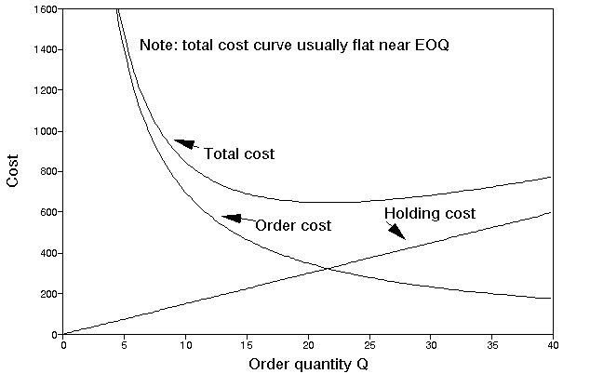
With this EOQ we can calculate our total annual cost from the equation
Total annual cost = c_{h}(Q/2) + c_{o}(R/Q)
Hence for this example we have that
Total annual cost = (30 x 22/2) + (35 x 200/22) = 330 + 318.2 = £648.2
Note: If we had used the exact Q value given by the EOQ formula (i.e. Q=21.602) we would have had that the two terms relating to annual holding cost and annual order cost would have been exactly equal to each other
i.e. holding cost = order cost at EOQ point (or, referring to the diagram above, the EOQ quantity is at the point associated with the Holding Cost curve and the Order Cost curve intersecting).
i.e. (c_{h}Q/2) = (c_{o}R/Q) so that Q = (2Rc_{o}/c_{h})^{0.5}
In other words, as in fact might seem natural from the shape of the Holding Cost and Order Cost curves, the optimal order quantity coincides with the order quantity that exactly balances Holding Cost and Ordering Cost.
Note however that this result only applies to certain simple situations. It is not true (in general) that the best order quantity corresponds to the quantity where holding cost and ordering cost are in balance.

Package solution
We can also solve this problem using the package, the input and output being shown below. Note here that the package can deal with more complicated factors than we have considered in the simple example given above.
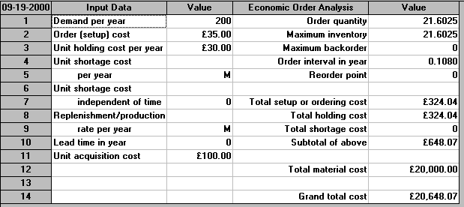
Note the appearance here of the figure of 20,000 relating to material cost. This is calculated from using 200 units a year at a unit cost of £100 each. Strictly, this cost term should have been added to the total annual cost equation (c_{h}(Q/2) + c_{o}(R/Q)) we gave above. We neglected it above as it was a constant term for this example and hence did not affect the calculation of the optimal value of Q. However, we will need to remember to include this term below when we come to consider quantity discounts.

Extensions
In order to illustrate extensions to the basic EOQ calculation we will consider the following example:
A company uses 12,000 components a year at a cost of 5 pence each. Order costs have been estimated to be £5 per order and inventory holding cost is estimated at 20% of the cost of a component per year.
Note here that this is the sort of cheap item that is a typical non-JIT item.
- What is the EOQ?
Here R=12000, c_{o}=5 and as the inventory holding cost is 20% per year the annual holding cost per unit c_{h} = cost per unit x 20% = £0.05 x 0.2 per unit per year = 0.01.
Hence EOQ = (2Rc_{o}/c_{h})^{0.5} = (2 x 12000 x 5/0.01)^{0.5} = 3464
The package output for this problem is shown below.
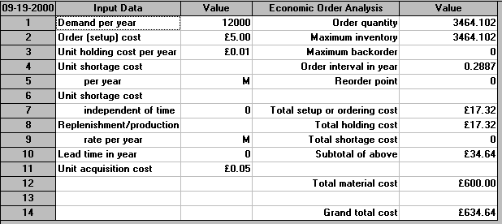

- If orders must be made for 1,2,3,4,6 or 12 monthly batches what order size would you recommend and when would you order?
Here we do not have an unrestricted choice of order quantity (as the EOQ formula assumes) but a restricted choice as explained below.
This is an important point - the EOQ calculation gives us a quantity to order, but often people are better at ordering on a time basis e.g. once every month.
The output from the package is shown below. Notice in that output how the package is considering the same choices (EOQ's and breakpoints) as in our manual calculation above.
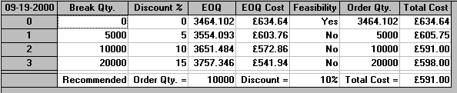
Note here the use of discount analysis is not restricted to buyers, it can also be used by a supplier to investigate the likely effects upon the orders he receives of changes in the discount structure. For example if the supplier lowers the order size at which a particular discount is received then how might this effect the orders he receives - will they become bigger/smaller, less frequent/more frequent?

Newsvendor problem
Consider a newsvendor who stands on the street and sells an evening paper, the Evening News. How many copies should he stock?
He sells the paper to his customers for 35 (pence) a copy. He pays his supplier 20 (pence) a copy, but any unsold copies can be returned to the supplier and he gets 10 (pence) back. This is known as a salvage value. Assume that his demand for copies on any day is a Normal distribution of mean 100 and standard deviation 7.
Before we can compute the amount he should order we need to work out his shortage cost per unit - how much does he lose if a customer wants a copy and he does not have a copy available?
As a first analysis he loses his profit (= revenue - cost = 35 - 20 =15) so we can estimate his shortage cost (opportunity cost) as 15 (this ignores any loss of goodwill and any loss of future custom that might result from a shortage).
Giving this information to the package we get:
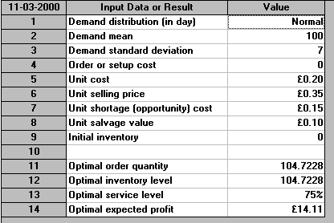
This tells us he should stock 104.7 (say 105) copies of the paper. This service level of 75% means that, on average, he will be able to completely supply his customers on 75 days in every 100, i.e. 3 days out of 4. The remainder of the time (1 day out of 4) he will experience shortages, some customers will not be able to buy a copy from him as he will have run out.
More sophisticated variants of this simple model can be used, for example, to decide how many copies of a magazine to have on a shelf in a newsagent (such as W.H.Smith).
Note that there is an important conceptual difference between this newsvendor problem and the EOQ/discount problems considered above. In those EOQ/discount problems we had a decision problem (how much to order) even though the situation was one of certainty - we knew precisely the rate at which we used items. In the newsvendor problem if we knew for certain how many customers will want a paper each day then the decision problem becomes trivial (order exactly that many). In other words:
- for the EOQ problem we had a decision problem even though there was no uncertainty
- for the newsvendor problem it was only the uncertainty that created the decision problem

Comment
There are many extensions to the simple EOQ models we have considered - for example:
- reorder lead time - allow a lead time between placing an order and receiving it - this introduces the problem of when to reorder (typically at some stock level called the reorder level). from the package input that the package allows for a reorder lead time.
- stockouts - we can allow stockouts (often called shortages) i.e. no stock currently available to meet orders. You will see from the package input that the package allows for shortage costs.
- often an order is not received all at once, for example if the order comes from another part of the same factory then items may be received as they are produced. You will see from the package input that the package allows for a replenishment or production rate.
- buffer (safety) stock - some stock kept back to be used only when necessary to prevent stockouts.

